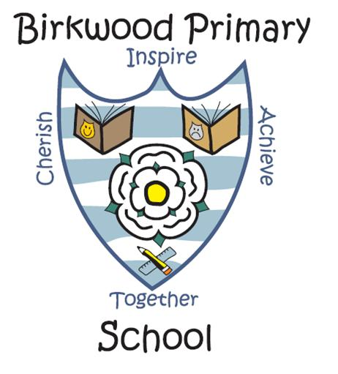Birkwood Primary School
Volunteer’s Agreement

We, at Birkwood Primary School, welcome all work experience and student help and support both inside and outside of the classroom.

Coming into school to work alongside children in the classroom is a position of trust between volunteer and school.

Due to the sensitive nature of working with children and dealing with sensitive matters which occur on a daily basis, the trust held between school and volunteer needs to be explicit.

Now that you are coming into school to support our work, we request that you observe fully the following points:

- If a child discloses any information to you that is of concern, you must alert the class teacher and the Headteacher
- Follow all activity instructions given by the staff in order to comply with health and safety regulations
- All children’s information is strictly confidential and MUST NOT be shared outside the classroom
- Note the location of the fire escapes and the procedure to follow in the event of a fire
- We have a high expectation of children’s behaviour and needs, because of our professionals understanding of those needs we sometimes work with and react to children in different ways, this professionalism should be respected at all times

We thank you for the time you are dedicating to supporting our work in school, and know that because of your partnership with us all of our children will benefit.

Mr Daniel Wood
Headteacher

I ___________________ agree to fully observe the Volunteers of Birkwood Agreement. I understand that it is only by fully complying with the statements above that I can continue to support in the classroom.

SIGNED: _____________________ DATE: __________________

