Using ‘a’ and ‘an’ correctly

Use ‘an’ before a word that starts with a vowel sound.
Vowel Sounds: a , e , i , o , u
For example: an umbrella
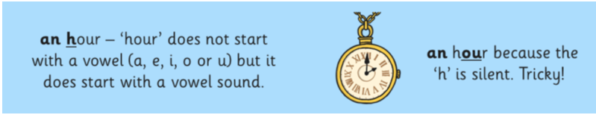
However:

Write ‘a’ or ‘an’ for each of these images:

____________________ ____________________ _____________________


  

