WALT: Make a travel brochure
WILF:
I can write a title and subheadings.
I can use phonics to help write words.
I can write some tricky words correctly.
I can use full stops and capital letters.
I can use exclamation marks and question marks.

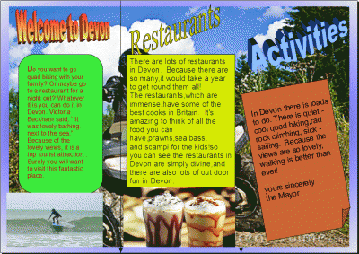
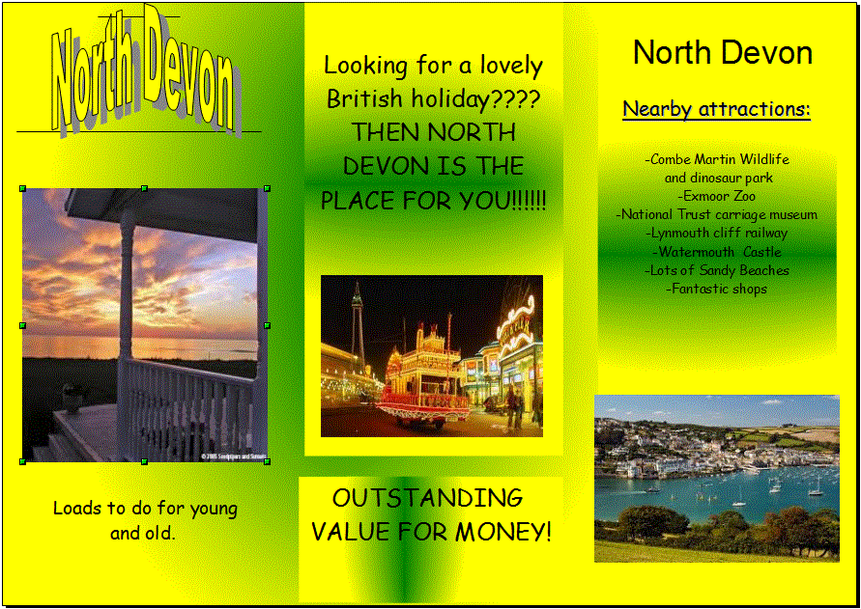
Can you make a travel brochure about the UK?

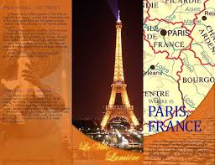

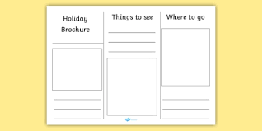
Here is a template you could use!

