WALT: to write a setting description about the Chocolate Room in Charlie and the Chocolate Factory.
WILF:
- To use capital letters and full stops correctly.
- To use interesting adjectives.
- To use different conjunctions (coordinating and sub-ordinating).

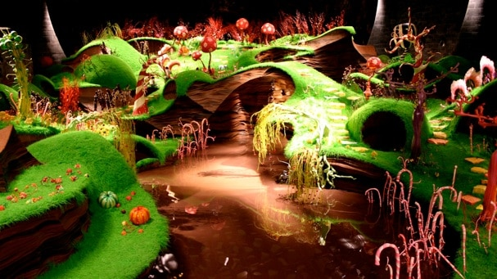
Imagine you are in the Chocolate Room with Willy Wonka.
What can you see?
What can you smell?
What can you hear?
What can you touch?
Write a setting description using all of your senses.
________________________________________________________________________________________________________________________________________________________________________________________________________________________________________________________________________________________________________________________________________________________________________________________________________________________________________________________________________________________________________________________________________________________________________________________________________________________________________________________________________________________________________________________________________________________________________________________________________________________________________________________________________________________________________________________________________________________________________________________________________________________________________________________________________________________________________________________________________________________________________________________________________________________________________________________________________________________________________________________________________________________________________________________________________________________________________________________________________________________________________________________________________________________________________________________________________________________________________________________________________________________________________________________________________________________________________________________________________________________________________________________________________________________________________________________________________________________________________________________________________________________________________________________________________________________________________________________________________________________________________________________________________________________________________________________________________________________________________________________________________________________________________________________________________________
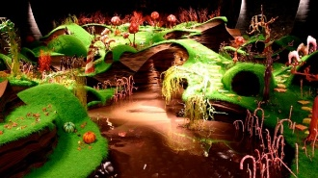
Write your own adventure story about the school turning into Willy Wonka’s Chocolate Factory.
- To use capital letters and full stops correctly.
- To use different conjunctions (coordinating and sub-ordinating).
- To use adverbs (slowly, quickly, carefully)
What adventure do you go on?
___________________________________________________________________________________________________________________________________________________________________________________________________________________________________________________________________________________________________________________________________________________________________________________________________________________________________________________________________________________________________________________________________________________________________________________________________________________________________________________________________________________________________________________________________________________________________________________________________________________________________________________________________________________________________________________________________________________________________________________________________________________________________________________________________________________________________________________________________________________________________________________________________________________________________________________________________________________________________________________________________________________________________________________________________________________________________________________________________________________________________________________________________________________________________________________________________________________________________________________________________________________________________________________________________________________________________________________________________________________________________________________________________________________________________________________________________________________________________________________________________________________________________________________________________________________________________________________________________________________________________________________________________________________________________________________________________________________________________________________________________________________________________________________________________________________________________________________________________________________________________________________________________________________________________________________________________________________________________________________________________________________________________________________________________________________________________________________________________________________________________________________________________________________________________________________________________________________________________________________________________________________________________________________________________________________________________________________________________________________________________________________________________________________________________________________________________________________________________________________________________________________________________________________________________________________________________________________________________________________________________________________________________________________________________________________________________________________________________________________________________________________________________________________________________________________________________________________________________________________________________________________________________________________________________________________________________________________________________________________
________________________________________________________________________________________________________________________________________________________________________________________________________________________________________________________________________________________________________________________________________________________________________________________________________________________________________________________________________________________________________________________________________________________________________________________________________________________________________________________________________________________________________________________________________________________________________________________________________________________________________________________________________________________________________________________________________________________________________________________________________________________________________________________________________________________________________________________________________________________________________________________________________________________________________________________________________________________________________________________________________________________________________________________________________________________________________________________________________________________________________________________________________________________________________________________________________________________________________________________________________________________________________________________________________________________________________________________________________________________________________________________________________________________________________________________________________________________________________________________________________________________________________________________________________________________________________________________________________________________________________________________________________________________________________________________________________________________________________________________________________________________________________________________________________________
________________________________________________________________________________________________________________________________________________________________________________________________________________________________________________________________________________________________________________________________________________________________________________________________________________________________________________________________________________________________________________________________________________________________________________________________________________________________________________________________________________________________________________________________________________________________________________________________________________________________________________________________________________________________________________________________________________________________________________________________________________________________________________________________________________________________________________________________________________________________________________________________________________________________________________________________________________________________________________________________________________________________________________________________________________________________________________

Adventure Story Checklist

Full stops at the end of every sentence.
Capital letters at the start of every sentence and for names.
Exclamation mark
Question mark
Apostrophes for possession (Miss Bell’s hair is brown).
Inverted commas for direct speech “Can I have a chocolate bar?” said Anna.
Using ‘a’ and ‘an’ correctly.
Use time conjunctions (before, after).
Use cause conjunctions (because, so).
Use prepositions (outside, in, on, inside).
Paragraphs
Cursive joined up handwriting.
Adverbs (slowly, quickly, at on o’clock).
Using the correct tense.

