WALT: to write an informal letter.
WILF:
- To set out my letter correctly (address, date).
- To maintain the correct tense.
- To use a range of punctuation (full stops, exclamation marks, question marks, commas).
- To use ‘a’ and ‘an’ correctly.

Have a look at the informal letter attached. Take a look at how the letter is set out especially where the address is and how they finish the letter.
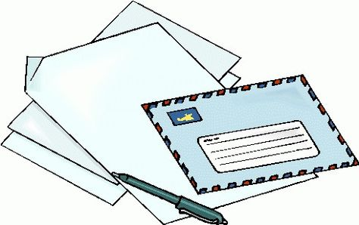

Writing Task:
I would like you to write an informal letter to me!
You could tell me about what you have been doing, any books you have read, if you’ve made anything or if you’ve been outside in the garden. It’s up to you!

If you want to send me your letter when you have finished you are more than welcome too. You can email me your letter or post it to school.
My email address is a.bell@smat.org.uk

