WALT: to write a character description.
WILF:
- To join most of my letters.
- To use apostrophes for possession.
- To use interesting adjectives (you might want to use a thesaurus)
- To use conjunctions to expand my sentences.

Writing Task:
I would like you to write a character description about anyone you like.
It could be a celebrity, a family member or somebody else.

Remember to describe them in detail:
What do they look like?
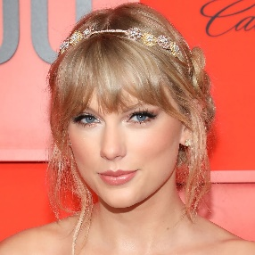
What are they wearing?
What do they smell like?
Are they tall or small?
Recap: Apostrophes for possession
Miss Bell’s hair is brown.
Bob’s skin is green.

When you have finished your writing, why not draw a picture of your person?

________________________________________________________________________________________________________________________________________________________________________________________________________________________________________________________________________________________________________________________________________________________________________________________________________________________________________________________________________________________________________________________________________________________________________________________________________________________________________________________________________________________________________________________________________________________________________________________________________________________________________________________________________________________________________________________________________________________________________________________________________________________________________________________________________________________________________________________________________________________________________________________________________________________________________________________________________________________________________________________________________________________________________________________________________________________________________________________________________________________________________________________________________________________________________________________________________________________________________________________________________________________________________________________________________________________________________________________________________________________________________________________________________________________________________________________________________________________________________________________________________________________________________________________________________________________________________________________________________________________________________________________________________________________________________________________________________________________________________________________________________________________________________________________________________________________________________________________________________________________________________________________________________________________________________________________________________________________________________________________________________________________________________________________________________________________________________________________________________________________________________________________________________________________________________________________________________________________________________________________________________________________________________________________________________________________________________________________________________

