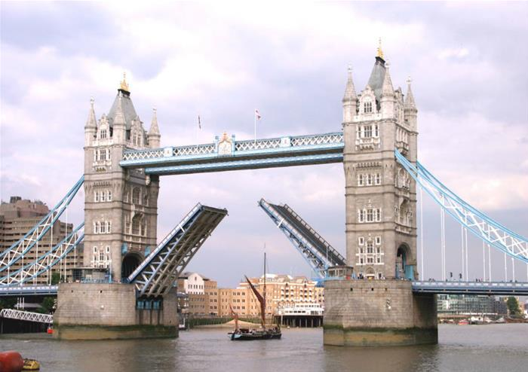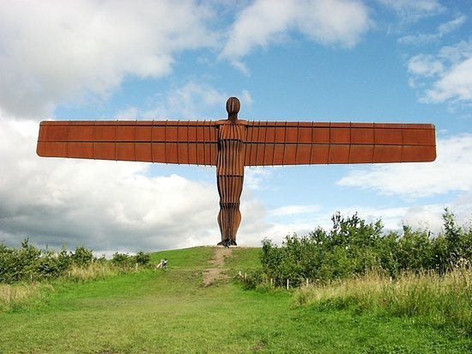
Tower Bridge Angel of the North
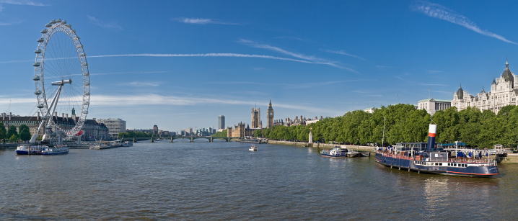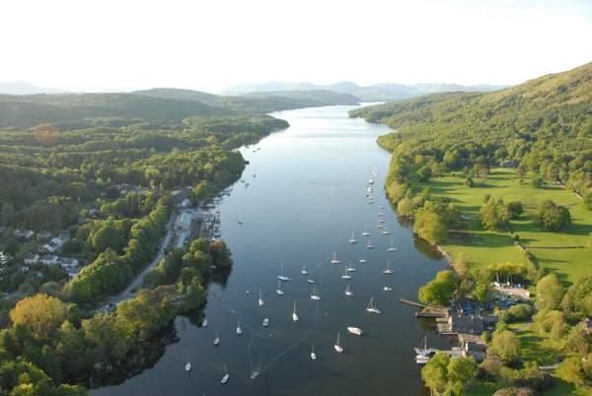
River Thames Lake Windermere

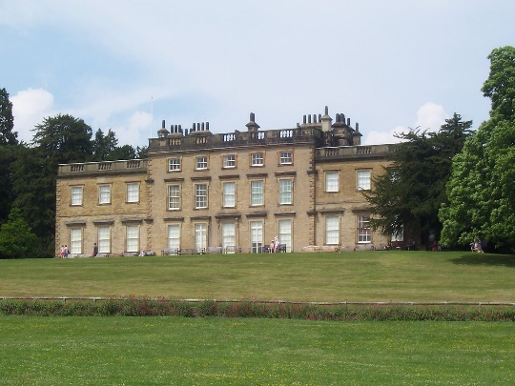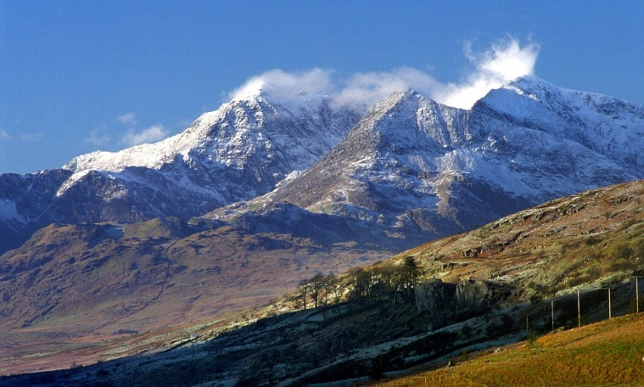
Cannon Hall Snowdon

WALT: Understand the difference between physical and human geography

Can you cut out (or draw) the photos from the first sheet? Are they physical geography features or human geography?
Sort them into the table below:
Physical Geography (natural) | Human Geography  (man-made)

CHALLENGE:
Can you draw one more feature of your choice for physical and/or human geography?

