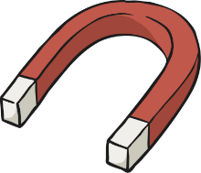
Forces and Magnets: Pushes and Pulls
What is a force?
A force is a push or pull acting on an object as a result of the object's interaction with another object.
Forces can make objects stop or start moving.

Have a look at this website. There is a fun video clip that explains what a force is and there is more information on the website:
https://www.bbc.co.uk/bitesize/topics/zvpp34j/articles/zywcrdm

We use push and pull forces all of the time. For example when you walk through a door you either pull the door handle or push the door to open it!
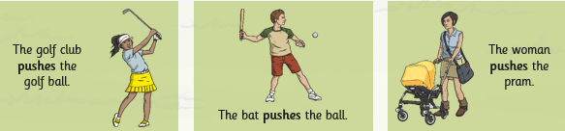
Here are a few examples of when we use the two different forces.

Task 1:
Can you create your own freeze frame of a pull and a push force? For example, you could pretend to be pushing a trolley for a push force. You could even take pictures of your freeze frames if you like!

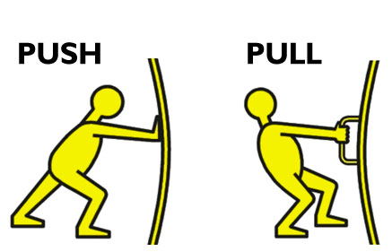

Task 2:
Cut out the pictures on the next page and sort them into ones that require a push force and ones that require a pull force.

