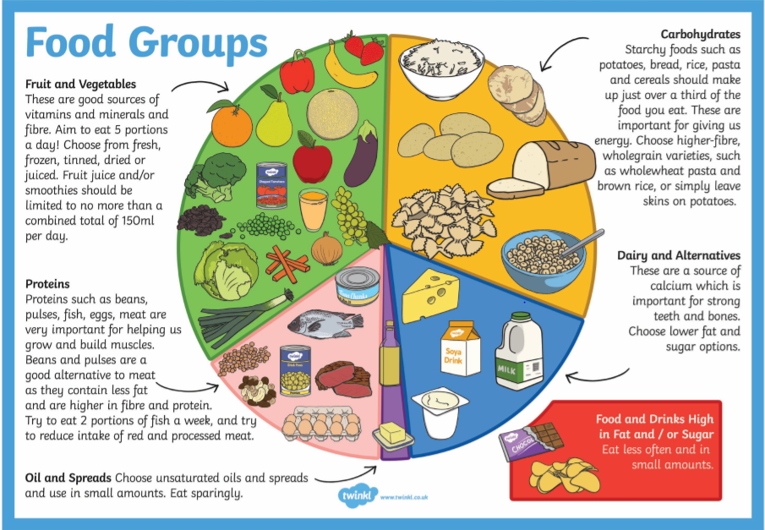

Task 1: Can you place the foods into the correct part of the Eatwell plate?
Food List
chocolate
carrots
pasta
peas
crisps
cheddar cheese
ciabatta
roast beef
strawberry milkshake
orange juice
nuts
doughnut
cous cous
fromage frais

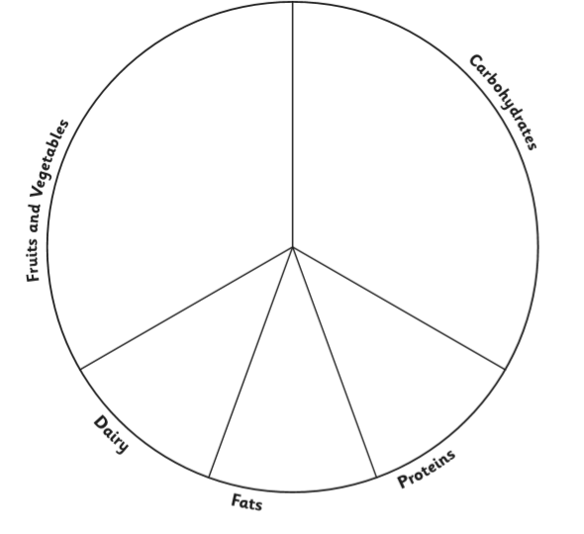

Task 2:
Can you create your own three course menu that contains the different parts of the Eatwell plate?
You can draw it, write it or even make it!
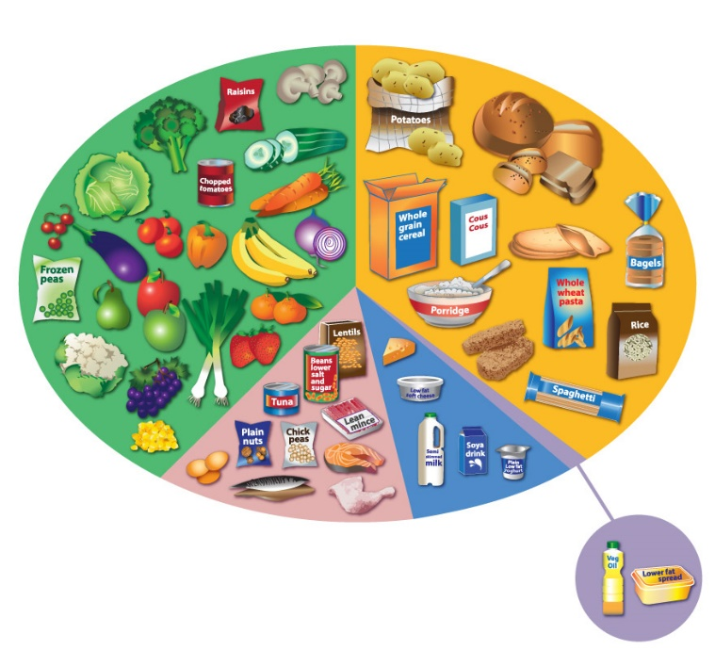
Please if you can take pictures of what you create and put them on our school twitter page or email me them. I can’t wait to see what you create!

