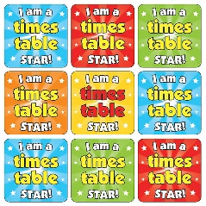
Times table Bingo!
Why not play times table bingo against someone in your family?
Draw a grid like the one below and write in any of these answers from the 4 times table:
4, 8, 12, 16, 20, 24, 28, 32, 36, 40, 44, 48
Ask someone in your family to read out calculations for example “4 x 4” - you have to work out the answers and cross them off if you have them. First person to cross all of their numbers wins!
You can play it again with the 3, 5, 6 or 8 times tables too!

