This is your homework for next half term.
Try and have a go at all the activities and let us know how you get on. You can bring it in to show us, send us a photo or video on Twitter (@stmarysbarnsley) or tell us when you’ve completed them.
Read | Make | Go outside and…
Learn all about light and how it works:  https://www.sciencekids.co.nz/light.html  Read the questions about the light spectrum and answer the questions in full sentences.  Your own book at least 3 times a week. Can you devise your own Guided Reading style questions for it? | Follow the ‘Building a Kaleidoscope’ instructions. Can you build your own kaleidoscope? Can you explain scientifically how it works? | In 1666, Newton made a discovery about light that led him to develop his Theory of Colour, a theory that still informs our understanding of light today. He placed a prism in front of ray of light, and his observations were incredible.  Let the sun shine through a transparent prism, and hold a piece of white card in front of the refracted ray of light as it leaves the prism.  Can you explain what is happening?
Investigate

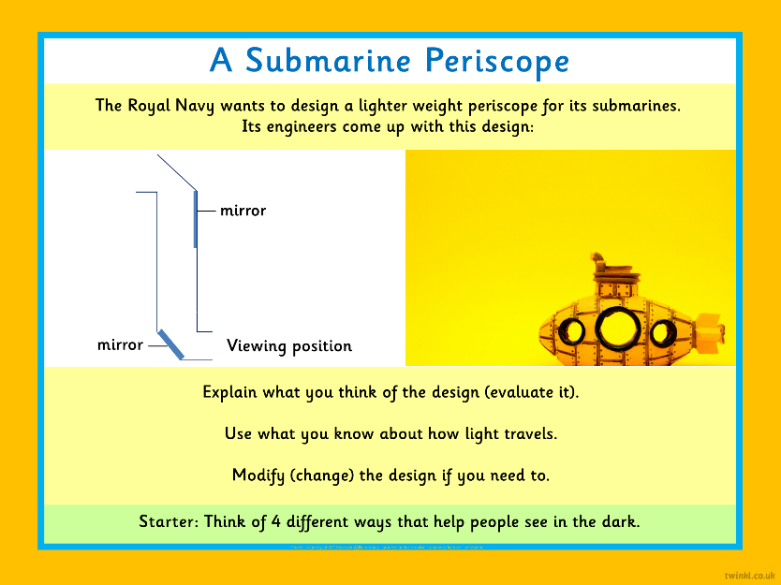

Tell
Give a presentation on white light.
How does it travel? Find out as much as you can. Use scientific vocabulary in your presentation (see find out section)
Write | Find out | Practise
Isaac Newton was an English scientist and mathematician. His ideas and discoveries are still considered to be important today.  Research Sir Isaac Newton and what he found out about light. What other discoveries did he make? | What do each of these words mean?  - Translucent  - Medium  - white light  - prism  - spectrum  - refraction | - Use your SATS revision books to keep up practicing your SPAG, Reading, and Maths skills.  - Keep up particularly learning about fractions and everything you learnt in Y6 – Improper fractions, adding and subtracting fractions, multiplying fractions and dividing fractions by whole numbers.  - Past SATS papers are available at:  https://www.satspapers.org.uk/Page.aspx?TId=5

