Subtraction
Have a go at using the column method to subtract these three digit numbers. You will have to exchange.
Remember our saying ‘pop next door to get ten more’ For example:
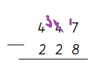

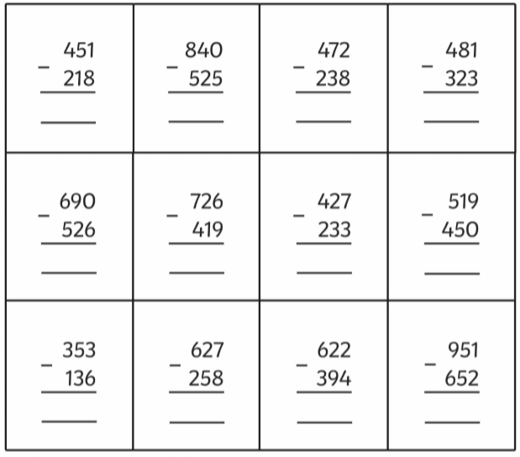
2 1 9
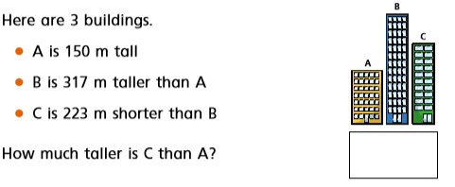
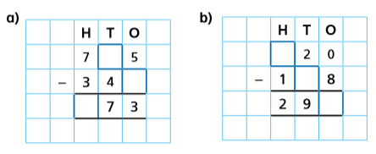
Work out the missing digits:

