Diwali is a festival that is celebrated by Hindus all around the world. It is often talked about as ‘the festival of light’ because of the tradition of oil lamps that people use to light homes, shops and public places. This colourful celebration takes place over three to five days and marks the start of the new year. During the festivities, families and friends come together to celebrate. The date changes each year however it usually falls at the end of October or in early November.
Diwali

The second day is another day for preparations. Henna is painted on hands and food is prepared for the third day.
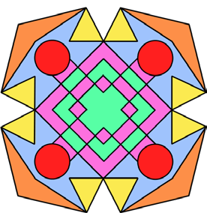
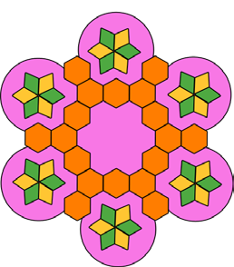
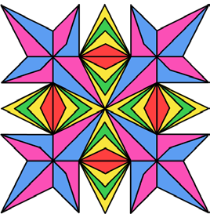
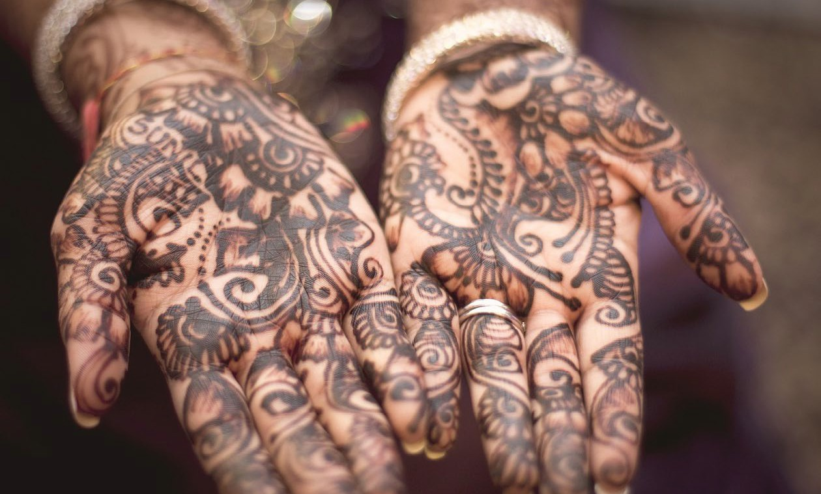

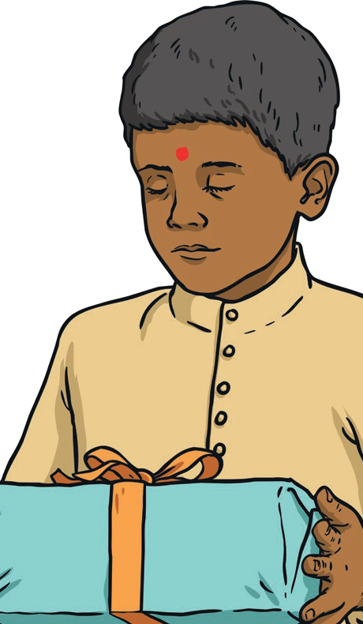
Diwali
The third is the day of Diwali - the main festival day. Best clothes and jewellery are worn, lamps are lit and prayers are said to Lakshmi – the goddess of wealth and good fortune. Hindus believe that Lakshmi walks the earth on Diwali night so people will put lamps outside and open their doors and windows to welcome her inside their homes. Family and friends visit each other, give gifts and enjoy food together. Firework displays also take place. The day after Diwali is when husbands and wives celebrate their marriage and Bhai Dooj is the final day of Diwali. On this day, brothers and sisters show their love by saying prayers for each other.
good over evil and light over
Diwali is a festival to celebrate the victory of
darkness. In the story of Rama and Sita, Rama and his wife were told by his father and mean stepmother that they must go and live in the forest. Whilst living in the forest, Ravana the demon king captured Sita. Rama’s friend, Hanuman the monkey king, found Sita on an island. Rama killed Ravana and rescued Sita. Rama and his wife safely returned home to their land. People lit lamps and put them in their windows to welcome them back.
The festival is also celebrated by Hindus, Jains, Sikhis and Newar Buddhists. They remember the release of Guru Hargobind and 52 princes from prison in 1619.

Reading Questions

- Fill in the missing words.
__________________ is a festival that is _____________ by Hindus all ______________________.
- Circle one answer.
Over how many days does Diwali take place?
3 days
6 days
5 days
7 days
- What is the first day of Diwali a time for?
___________________________________________________________________________
- What happens the day after Diwali? Tick two.
Families have a party to celebrate.
Husbands and wives celebrate their marriage. Brothers and sisters say prayers for each other.
People put lamps outside and open their doors and windows.

- What is Lakshmi the goddess of? Tick one. The goddess of thunder and lightning. The goddess of hope
The goddess of love
The goddess of wealth and good fortune

- Read the following statements and decide whether they are true or false.
Diwali is a festival to celebrate the victory of good over evil.
Rama and his wife were told to go and live in the forest.
Diwali is also celebrated by Sikhs.
Hanuman was a demon king who captured Sita.

Why not create your own Rangoli pattern? You could draw it, paint it or even use objects!
