WALT: Solve money problems
Have a go at these problems involving giving change:
I buy a book that costs £3

I pay for it using £5 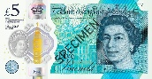

How much change should I get?

I buy two cars that cost £4 each 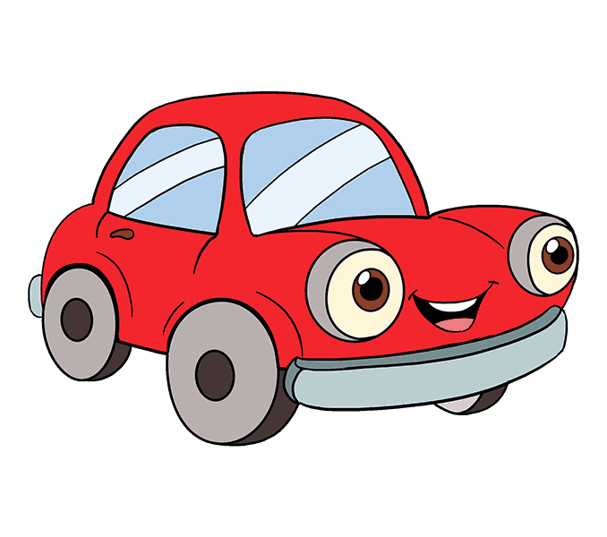
I pay for them using £10 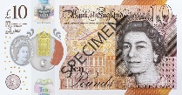

How much change should I get?

I buy this teddy for £13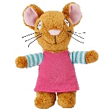

How much change will I get from £20? 