WALT: Recognise and add coins
How much is in each purse? Add the value of the coins and write the total.

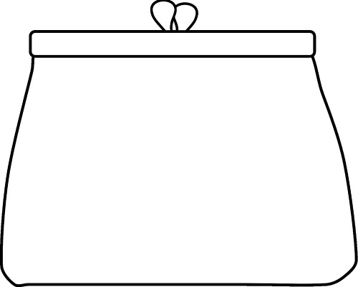

CHALLENGE:
Can you draw your own purse with coins in to make a set amount? Ask an adult to check!

