WALT: Locate places on a map
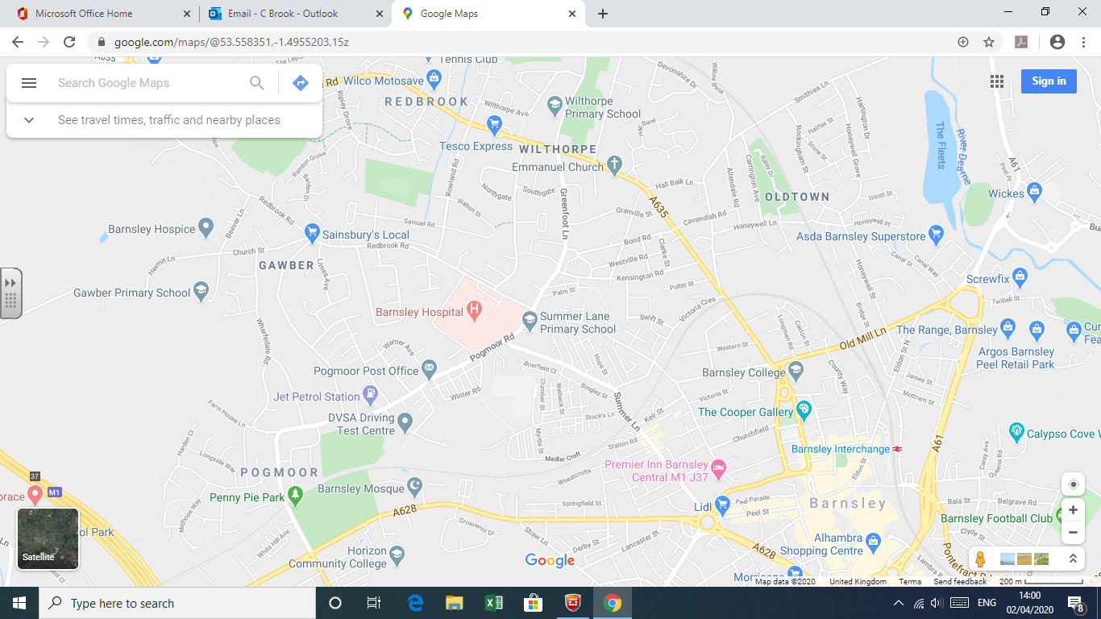
Can you…
CHALLENGE:
Can you plan a route from Pogmoor Post Office to The Cooper Gallery?
- Find St Mary’s Primary School?
- Find where you live? (If it is on the map)
- Find Penny Pie Park?
- Find the rail station?

