Learning Through Play

- Make up stories, dress up, use or make puppets. The use of spoken story language eg once upon a time, then, next, the end is a fantastic tool to help in reading.
- Send a message to one of your friends from school. This could be a letter, a text or a FaceTime. This doesn’t have to be written. Children forming sentences verbally is part of our curriculum too!
- Freeze some small toys in ice. Use this as a science experiment. Make predictions, try different ways of melting them, time how long it takes.
- Make a scrapbook using family photos. Discussing people along with their similarities and differences is one of our Early Learning Goals!
- Set challenges when playing with toys eg cars, blocks, lego. Counting, measuring or grouping objects is a quick and easy way to fit some Maths into play.
- Washing up liquid and a few drops of food colouring is fantastic for creating some bubble pictures. Drop pieces of paper on top and see what patterns you get.
- Set up a treasure hunt, you could get into character and learn some pirate phrases! Design a map, stain it with coffee and write some labels to help find the treasure. This is a quick way to get some writing into play and the use of directional language is in our Maths curriculum.
- Add some French counting into play, how many times can you bounce a ball counting in French?
- You can create your own messy tray at home to practice number and letter formations without the pen and paper. Similar to our glitter tray at school. You could use a baking tray filled with rice, sand, glitter, flour, sugar, salt, soil. Your choice!
- Fill a bag with random objects from around the house. All of our children know the magic bag song by now! Can they guess what the object they ca n feel is and sound out the word eg p-e-n s-w-ee-t
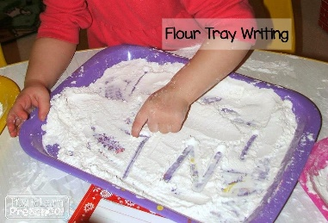
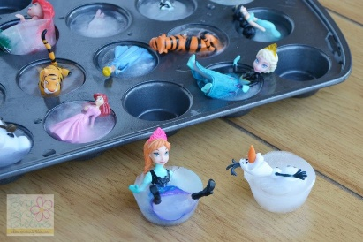
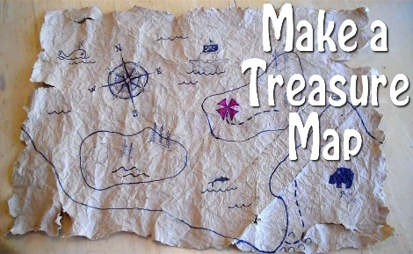
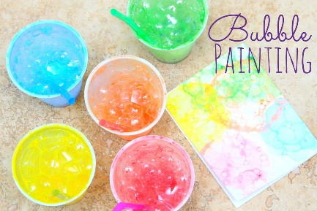
Hope this helps! Miss Gulliver x

