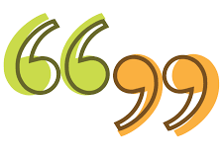
Task 2:
Now you have inserted the inverted commas into the sentences, I want you to now have a go at using inverted commas correctly.

Inverted Commas are used for direct speech.
inverted commas, talking, talking, talking, a piece of punctuation, inverted commas
For example:
Miss Bell exclaimed, “I love chocolate!”

Task:
Write a conversation between two people.
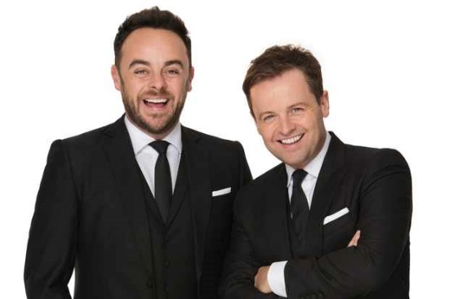
It could be two characters from the TV/a game, it could be between you and someone in your family or even between you and me! It can be about anything you like but make sure you don’t forget your inverted commas for any direct speech!

