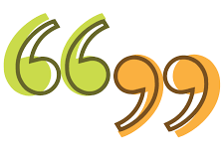
Inverted Commas are used for direct speech.
Do you remember our song?
inverted commas, talking, talking, talking, a piece of punctuation, inverted commas
For example:
Miss Bell exclaimed, “I love chocolate!”

Task:
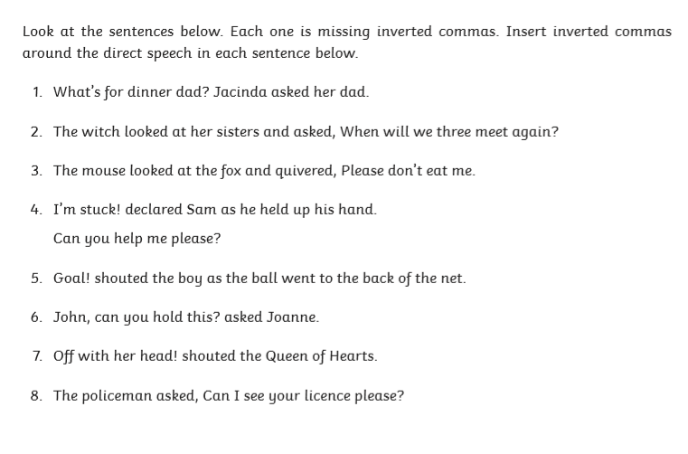
Can you spot the missing inverted commas? Re-write the sentences so they have inverted commas in the correct places.

