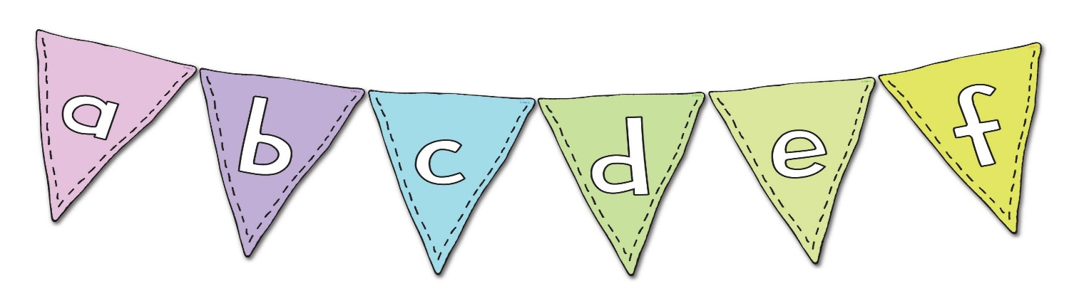

Initial sound game

Rules: You can play this game against the clock and set a timer or just have a competition with your family. Take it in turns to choose a letter of the alphabet, you then have to each think of and write down an answer starting with that letter for the following categories. Feel free to add your own too!

A food….

A film…

A TV show…

An animal…

A body part…

Something you can wear…

A song…

A celebrity…

