This is your homework for this half term.
Read | Make | Go outside and…
Continue to read your school books as often as you can!  Read any other books you find interesting! | Make a model of your house out of junk materials.  Make a map of your street.  Make a treasure map of your house and garden. | Go outside and look at what 2D and 3D shapes you can see.
 |  | Remember to stay safe!
Tell | Where we live  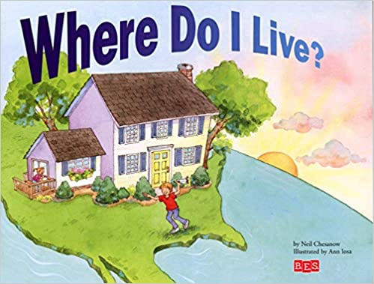 | Investigate
Someone your address.  Someone about where you would like to visit in the UK.  . |  | The different types of building around you and make a tally chart i.e. bungalow, flat, houses- detached, semi…  I can investigate the weather over 2 weeks and record this in my own chart.
Write | Find out | Practise
A draw a picture of a famous place, statue or building and write some facts about it! | About the capital cities of the UK and make a poster.  Look at this website:  https://www.bbc.co.uk/bitesize/topics/zyhp34j  Find out about different places | Writing all year 1 tricky words.  Try to write sentences using these words and similar words.  Your number bonds to 20.
Try and have a go at all the activities and let us know how you get on. You can bring it in to show us, send us a photo or video on Twitter (@stmarysbarnsley) or tell us when you’ve completed them.

