This is our homework grid for the next half term.
Our next topic after the Easter Holidays would have been ‘All things Spring’ looking at signs of Spring outside and mini-beasts with a book focus on Julia Donaldson’s ‘Superworm’.
Hopefully you can still enjoy these activities and are keeping safe at home!
Read | Make | Go outside and…
Our topic focus book ‘Superworm’  Don’t worry about getting hold of the book, there’s some fantastic readings of it for free on Youtube. Just type in ‘Superworm read aloud’.  Pause throughout the video and discuss what is happening in the story. Can you see any tricky words, digraphs, words you can read? | Your own Bug Hotel  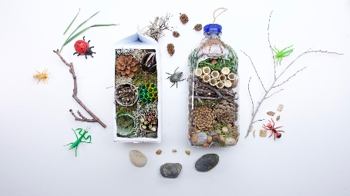  You could use all sorts from around the house for this, plastic bottle, toilet roll tubes, shoebox etc and then fill it with bits from the garden that bugs might like. Sticks, twigs, pinecones, grass, pebbles. Place it outside and see who visits your Bug Hotel! | Go on a mini-beast hunt, making a tally of how many you find  This could be in your own garden or on a walk, see how many different kinds of mini-beasts you can spot. Which did you see the most, the least?  This could be across the course of a day or however long you like. Do you think everybody will have the same answers?
 |  | Remember to stay safe!
Teach | 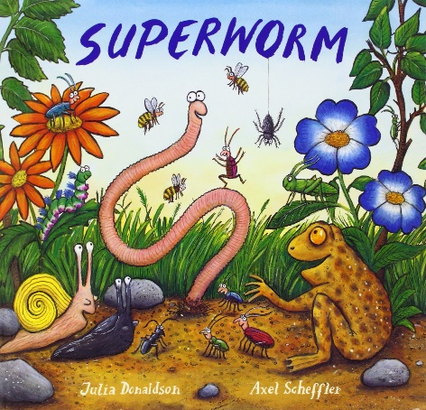 | Investigate
Teach a grown up a Phonics lesson!  You all have done brilliant in Phonics and love to pretend to be teachers so now is your time!  Make sure grown up’s are sat nicely! They need to practice the sounds we know and then teach them one of our new digraphs. What words can they write with the new sound in? |  | A mini-beast up close, remember to be gentle!  Using an iPad or a phone (with Mum or Dad’s permission of course!) zoom in using the camera on a mini-beast you have found.  Look carefully and make some notes of what you can see. How many legs does it have? How does it move? Can you see its eyes?
Write | Find out | Practise
A list of activities you have enjoyed doing whilst been at home  This can be on your own or with a grown-ups help. We have all had to be creative during this time and I’m sure some of you have come up with some new games or things to do.  This would be a fantastic way to share ideas between parents too! | How does a caterpillar turn into a butterfly?  There are some fantastic resources for this online including Youtube.  Write down some new words that are used during your research and what they mean eg cocoon  Could you draw a life cycle of the changes that happen? | Writing digraphs and putting these into words and sentences  We were all doing super at remembering our digraphs and had so far learnt sh, ch, th, ng, oo, ee, ai  Practice putting these into words and then into a sentence eg  sh  shop  I went to the shop.

