This is your homework for next half term.
Try and have a go at all the activities and let us know how you get on. You can bring it in to show us, send us a photo or video on Twitter (@stmarysbarnsley) or tell us when you’ve completed them.
Read | Make | Indoors …
Can you read any books or information texts about how animal skeletons help protect their bodies? | Make or design a meal that has the different elements of the Eatwell Plate (proteins, carbohydrates etc). | Can you do a different exercise every day?
 |  | Remember to stay safe!
Tell | 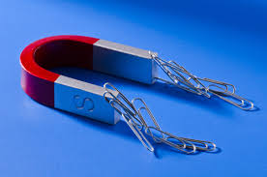  Forces and Magnets  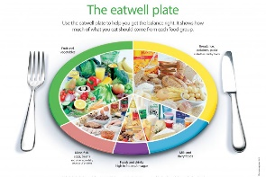  Animals including Humans | Investigate
Tell someone for example your Mum/Dad/Grandma/ Aunty/Friend facts about the Eatwell plate and the different types of foods everybody should try to eat. |  | Investigate which objects inside your house are magnetic.  How do you know?
Write | Find out | Practise
Write and design a menu for a restaurant.  Make sure it contains the right amounts of each type of food! | Find out six facts about magnets (the magnetic field, poles etc). | Handwriting- the letters: r, s, t and l  Spellings – see separate sheet.  Reading at home- keep recording every time you have read! The more you read the more chance of prizes!  Times tables – 4’s, 6’s and 8’s.  SPAG- adverbs and prepositions: can you use them in a sentence?

