Fraction of Amounts
Now we have found one third, one ninth etc we are going to look at finding more than one.
For example:
If I wanted to find -
2
of 12 =
3

- I would find one third first just like we did on the first task sheet. We divide 12 by 3.
12 ÷ 3 = 4
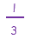
of 12 = 4

- However we want to find 2 thirds. So we multiply (times) our answer by 2.
4 x 2 = 8
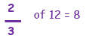

Example:
If I wanted to find -
4
of 25 =
5

- I would find one fifth first. We divide 25 by 5.
25 ÷ 5 = 5
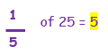

- However we want to find 4 fifths. So we multiply (times) our answer by 4.
5 x 4 = 20
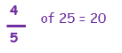

Now have a go at finding the fractions of these amounts:

3
of 16 =
4
2
of 21 =
3
3
of 24 =
4
4
of 36 =
6
5
of 32 =
8
2
of 65 =
5
2
of 18 =
3
4
of 42 =
6

