This is your homework for next half term.
Try and have a go at all the activities and let us know how you get on. You can bring it in to show us, send us a photo or video on Twitter (@stmarysbarnsley) or tell us when you’ve completed them.
Read | Make | Go outside and…
Some non-fiction articles about space by using this website:  https://www.popsci.com/read/space-articles-for-kids  Alternatively, have a read of this website – go on a NASA mission!  https://www.nasa.gov/kidsclub/index.html | A mobile of the Solar System.  A model of a rocket ship.  A model of an astronaut. | Play Space Mission games in the garden.  Enjoy the beauty of nearby walks, reservoirs or parks.  Observe the night sky – what planets or stars can you see?
 |  | Remember to stay safe!
Tell | Earth and Space  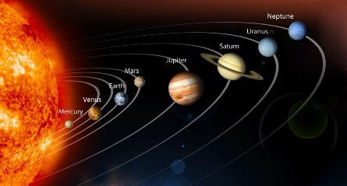 | Investigate
All about Sir Isaac Newton and what his contribution to Science was.  All about how day and night works and the role the moon plays in this. |  | Does a heavier object fall quicker than a lighter object? Conduct your own home science experiment to find out!  The daily life of Tim Peake.
Write | Find out | Practise
A diary entry in role as a Spaceman or woman on their very first mission.  A newspaper report on the Moon Landings. | About the Moon Landings in 1969!  About the Space Race between the USA and Russia. | Spellings  Times Tables – Use the Times Tables Rockstars website!

