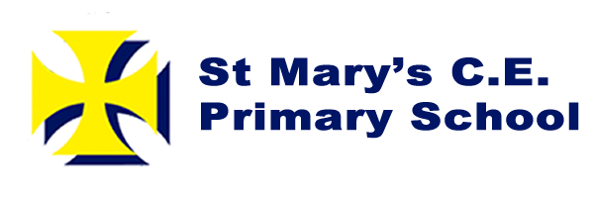

Hello!

We hope you are all well. Missing each and every one of you so much! Please remember these resources are there if you can and want to use them, the main aim throughout this uncertain time is that you are safe.

There are some new resources to use if you would like to, plus the homework grid that would have gone home for this upcoming half term. We would have been looking at ‘Where We Live’ in topic and the seasons.

In Maths we would be focusing on additions, subtractions, multiplications, divisions, money, time, place value.

In Literacy we would be looking at facts about the UK and using previous skills learnt such as making a travel brochure about places to visit and local landmarks. Writing sentences using full stops and capital letters, finger spaces, exclamation marks and questions marks.

Keep safe, Miss Pollard, Mrs Brook and Mrs Mellor

**Some useful websites and resources to use:**

* <https://www.twinkl.co.uk/resources/parents>
* <https://www.topmarks.co.uk/>
* <https://www.oxfordowl.co.uk/>
* <https://www.tts-group.co.uk/home+learning+activities.html>
* <https://www.phonicsplay.co.uk/>

<https://whiterosemaths.com/homelearning/>

<https://www.bbc.co.uk/bitesize/topics/zyhp34j>

<https://www.stem.org.uk/resources/community/collection/13195/year-1-seasonal-changes>

http://www.coreknowledge.org.uk/resources/Resource%20Pack-%20Year%201-%20Seasons%20and%20Weather.pdf

I hope you are all well if you need to contact us you can do this Twitter (@stmarysbarnsley) or contact school and leave a message.

Thank you,

Miss Pollard, Mrs Brook and Mrs Mellor

Year 1

Home Learning Pack 2