WALT: Write a fact book
Read and writing task book link
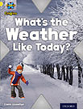
Look at the book on (oxfordowl website link below ebook)
https://www.oxfordowl.co.uk/
Read the book and try the activities 1 and 2.
Make a weather booklet and write about the four different types of weather we can have in the UK; sun, wind, rain and snow. What can you do when we have these weathers? Where could you go? What clothes do you need to wear?

