Addition
Have a go at using the column method to add these three digit numbers together. You will have to carry.
Remember to carry underneath the line. For example:

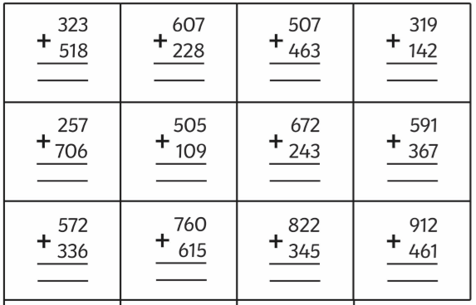
346
225
571
1

Find the missing digits:

Word Problem:
Dexter bakes 148 biscuits on Monday.
On Tuesday he bakes 275 more biscuits than he did on Monday.

- How many biscuits does Dexter bake on Tuesday?

- How many biscuits does he bake in total on Monday and Tuesday?

