Adding and Subtracting Fractions with the same denominator

The top number of a fraction is the numerator and the bottom number of a fraction is called the denominator.
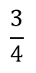
Numerator
Denominator

When we add and subtract fractions with the same denominator we only add the numerators. The denominator stays the same.
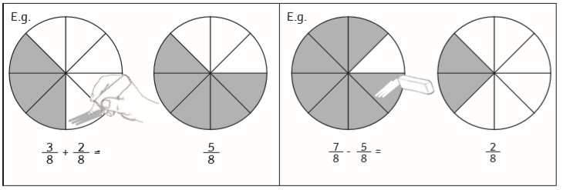
For example,

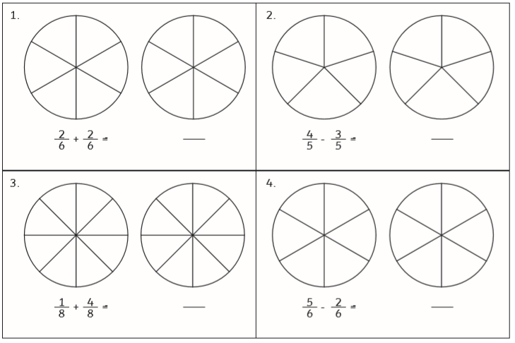
Have a go at using the circles to help you work out the answers.

Now have a go without the circles. Remember you only add the top numbers!
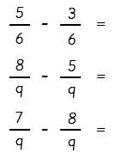
2 2
=
+
5 5
2 5
=
+
8 8
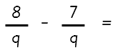
4 2
=
+
9 9
Word Problems:
Bob bought a pepperoni pizza. He ate four ninths of the pizza. Barbara then came along and ate three ninths of Bob’s pizza. How much of the pizza was left?

Billy ate 3 of a chocolate bar. Jade ate 6 of her chocolate bar.
8
8

How much more did Jade eat than Billy?

