Alphabet hunt  Inside or  Outside | Draw and name 5 insects you could find outside. | Write a shopping list of 10 items | Read a book outside | Print or write phase 3 sounds play ‘shoot the sounds’
Make a den/cave and read a story inside | Make the number bond 10 hands | Draw a superhero and write 5 super things they can do! | 2D and 3D shape hunt inside and outside | Play a game of hangman
Follow a recipe and bake something | Play guess my number ie. It is higher than 6 but lower than 8. What is my number? | Play a Card game | Play a Board game | Paint a picture of yourself
Make a paper spinner  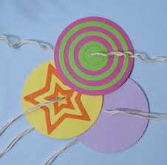 | Make a threading animal  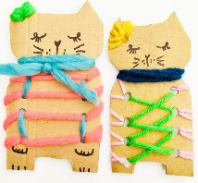 | Make a symmetrical butterfly  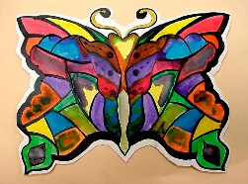 | Use water and a paint brush and write all the tricky words | Plan a picnic. What could we have? Help make it and set it up!
Play roll and add dice game  Investigate- What is largest number you can make? What is lowest? | Write instructions on how to make a sandwich | Design and make a building | Play shops using coins and notes. Adding items, finding change. | Write an alternative ending to a story
Things to try at home! See if you can complete a task and colour it in!

