Activities
Here is a grid of different activities you might want to have a go at trying. When you’ve done one you could tweet us or email me.
Build a den and read a book or write a story in your den. | Sing along to one of your favourite songs. | Design a character for a game or film. | Play a game of hangman.
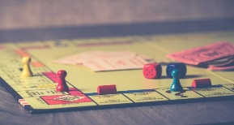  Play a board game. | Follow a recipe and bake something. | Draw, colour or paint a picture of yourself or a family member. | Make a paper spinner  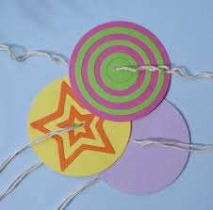
Build a tower maybe out of Lego, cardboard or any materials.  How tall can you make your tower? | Create a dance routine to one of your favourite songs. | Create a superhero. What special power will you give it? | Draw and design a treasure map for someone to follow.

