Gangsta Granny by David Walliams

Task: Provide adjectives for each of the characters listed below and give a reason for your choice.

Character | Adjectives | Reason
Ben
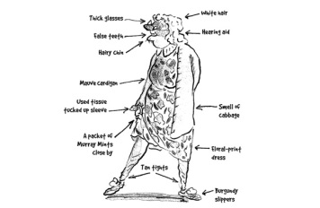
Granny
Mr Parker
Flavio Flavioli
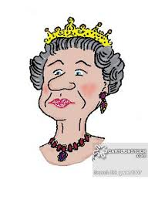
The Queen

Now, can you include your chosen adjectives in interesting, descriptive sentences?

