Convert between different units of measure

FLUENCY
A Complete the statements:
100cm = m 2cm = mm
45mm = cm 1km = m
6 ½ km = m 1500ml = l
3.5kg = g 500g = kg

B Use the word and number cards to complete the statements.
To change from cm to mm by
To change from kg to g by
To change from ml to l by
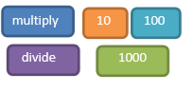

C Are these statements true or false?
1000m = 1km 1000cm = 1m
1000ml = 1l 1000g = 1kg
1000mg = 1g

REASONING
A The answer is 475 metres. What is the question?

B Hamid says ‘To convert kilometres to metres, add three zero’s on to the end of the number.’ Eg 2km=2000m
Do you agree with Hamid? Explain why.

C Laura is 2.72m tall. She is 59cm taller than her sister. How tall is her sister? Give your answer in centimetres.

D Put these amounts in order starting with the largest.
Half of 5 litres Quarter of 8 litres 700 ml
Explain your thinking.

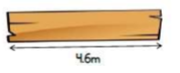
PROBLE SOLVING
A A plank of wood is 4.6m long.

Two lengths are cut from the wood: 225cm and ½ m
How much wood is left?

B James and Sita do a sponsored walk for charity. They walk 1.2km altogether. James walks double the amount that Sita walks. How far does Sita walk?

They each raise 75p for every 100m they walk. How much money do they each make?

